Project Management and Group Work
What is not a project?
- The operation of car manufacturing
- The operation of a call centre
These do not have a specific time limit. There are more repetitive stages or cycles.
The Gannt chart shows the tasks that you have on your project and how they are executed through time.
- When you start planning your tasks, you can decompose all the objectives of your project into smaller tasks, and then you can define how long they last, who’s responsible and the criticality of each task.
“Project management is the application of processes, methods, knowledge, skills and experience to achieve the project achievements”
-Association for Project Management (APM)
The benefits of standard methodology:
- Use of consistent terminology
- A common understanding of the responsibilities associated with roles
- Consistent documentation across projects
- A structure for development of new project managers
- Greater mobility of staff between projects
So what is a project?
- The pyramids were built over 4000 years ago. This is an example of a project. There were some constraints on time, material but you have a final product that was delivered for a specific purpose.

“It’s a temporary endeavor undertaken to create a unique product, service or result”
-Project Management Institute (PMI)

“A project is a unique, transient endeavour, undertaken to achieve planned objectives, which could be defined in terms of outputs, outcomes or benefits. A project is usually demmed to be a success if it achieves the objectives according to their acceptance criteria, within an agreed timescale and budget”
-Association for Project Management (APM)

Initiating a project
A program is a set of projects and projects start from an initial pitch
Afterwards, the processes of the project management occur.

Scope Management
- Success and benefits: understanding what success means for different stakeholders
- Objectives and requirements: comprehensive and measurable requirements are critical to project success
- Options and solutions: exploring multiple options until a preferred solution is identified
- Scope definition: the translation of requirements into outputs for the chosen solution
- Quality Planning: ensuring outputs are delivered in accordance with requirements.

Requirements management
The various requirements are assessed to ensure they are practical, achievable and define what is needed rather than how they will be achieved.
A well specified requirement is:
- uniquely identifiable
- current and relevant
- consistent
- understandable
- verifiable
- traceable
- prioritised
A very simple process for requirements management:
- Gather requirements from stakeholders
- Analyse the requirements to look for overlooked gaps and conflicts
- Justify the requirements to distinguish wants from needs
- Baseline the needs before commencing solutions development process.

Solutions development
Solutions development is the process of determining the best way of satisfying requirements.
- A simple requirements management process produces a clear set of baselined stakeholder requirements. A more sophisticated value management approach produces a baseline that includes ideas for alternative functionality that is more acceptable to stakeholders. Either way, the baseline requirements do not explain how to tackle the requiements.
- Solutions development explores the options forproject requirements and then implements the best solution.

Strategies to exploit innovation include…
- Prototyping – exploring the innovation with a base model
- The use of modelling, simulation and synthetic environemnt
- Phased implementation of new technology

Planning
Planning determines what is to be delivered, how much it will cost,when it will be delievered, how it will be delivered and who will carry it out.
Documentation will answer such questions like: why? What? How? Who? When? How much? Where?
- Project planning involves breaking down the work into parts and assign these to project team members, anticipate problems that might arise and prepare tentative solutions to these problems.
- The project plan, which is created at the start of a project, is used to communicate hoe the work will be done to the project team and customers, and to help assess progress.
Planning takes place…
- At the proposal stage, when you are bidding for a contract to develop or provide a software system.
- During the project startup phase, when you have to plan who will work on the project, how the project will be broken down in increments, how resources will be allocated across your project
- Periodically throughout the project
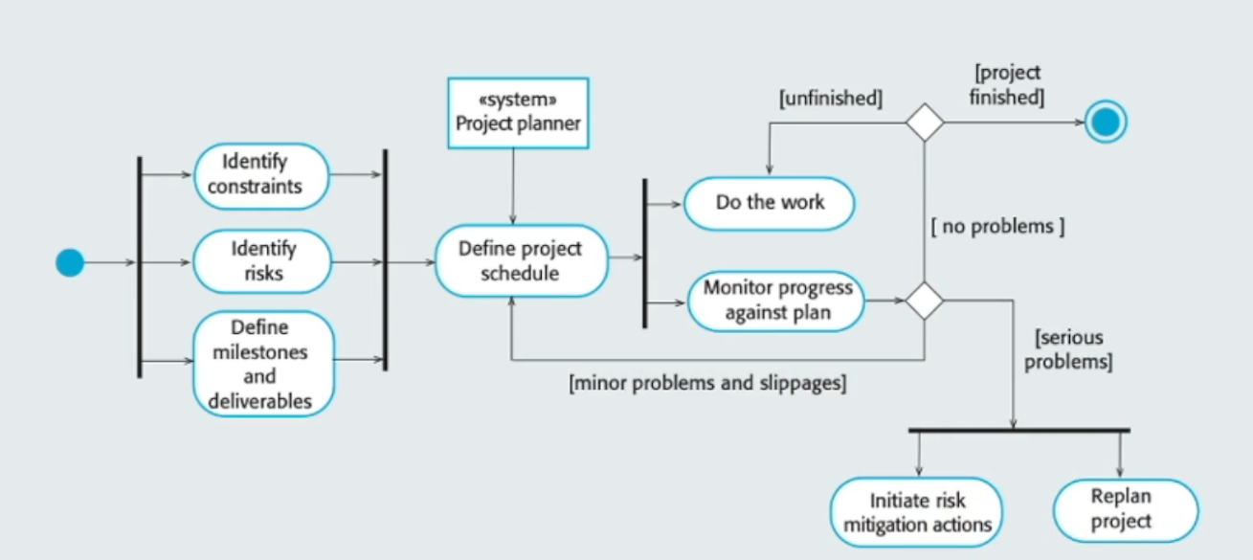

Tasks
Once you have objectives, you have to deliver tasks. List them, involve the team, organize logically (work breakdown structure, product breakdown structure, mindmap, board etc.) and consider granularity

Product Breakdown Structure (PBS)
In a PBS, you have a product and its sub products.
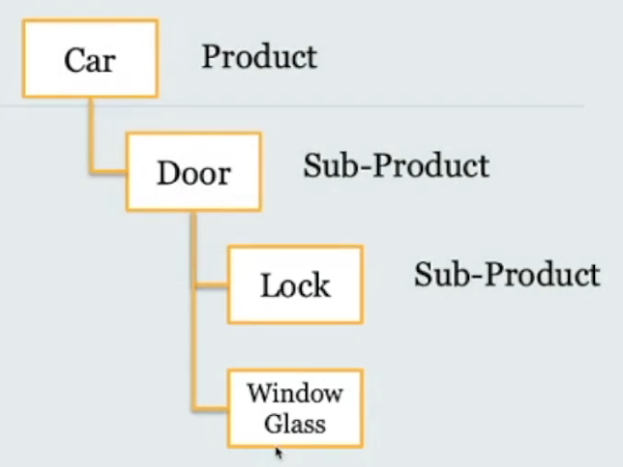

Work Breakdown Structure (WBS)
Here, you give details on how to handle the project.
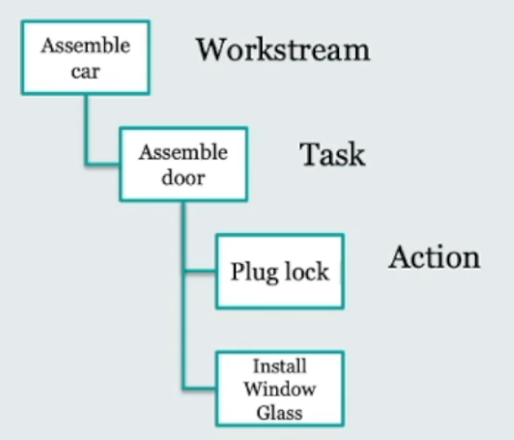

Schedules are presented in many different ways in order to suit the circumstances. The choice of presentation will depend upon:
- Level of detail required
- Whether time and/or resource is being shown
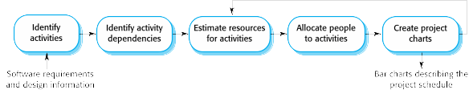
- The context of the work
- The dimension being scheduled
- The target audience

Budgeting and Cost control
Budgeting and cost control compromise the estimation of costs. Costs may be organised into a cost breakdown structure where different levels disaggregate costs into increasingly detailed categories.
Contingency is money set aside for responding to identified risks.
Be optimistic, realistic and pessmistic
Don’t promise average. Usually the realistic option is not the average.
Add a contingency.

Risk assessment
Risk management is a process that allows individual risk events and overall risk to be understood and managed proactively, optimising success by minimising threats and maximising oppurtunities.

The risk attitude:
- Risk averse, where risk is avoided
- Risk seeking, where risk is actively sought
- Risk neutral, where risk is neither actively sought nor avoided
Examples of project, product and business risks:
- Staff turnover – experienced staff will leave the project before it is finished
- Management change
- Hardware unavailability
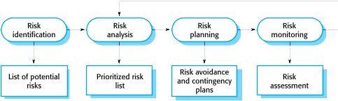
- Requirements change
- Specification delays
- Size underestimate
- CASE tool underperformance
- Technology change
- Product competition
Risk identification may be a team activity or based on the individual project manager’s experience.
A checklist of common risks may be used to identify risks in a project:
- Technology risks
- Organizational risks
- People risks
- Requirements risks
- Estimation risks
Consider each risk and develop a strategy to manage that risk.
- Avoidance strategies
- Minimization strategies
- Contingency plans

Risk monitoring
Assess each identified risks regularly to decide whether or not it is becoming less or more probable.
Also assess whether the effects of the risks have changed.
Each key risk should be discussed at management progress meetings.

Execution and group work
“The life cycle of something such as an idea, product or organization is the series of developments that take place in it from its beginning until the end of its usefulness”

Stakeholders management and group work
- Project working styles
- How to build/manage a team
- Group work and collaboration
- Creating safety in teams
- Motivation
- Your responsibilities as a team member

Some (project) working styles
- Action
- Social
- Planner
- Analysts

